Heat Exchanger Circuiting Patterns - “CondStruc.in” and “EvapStruc.in”
The data files of “CondStruc.in” and “EvapStruc.in” describe circuiting patterns of the condenser and evaporator, respectively. The two files are made in the same format. For a heat pump unit, the files of “CondStruc.in” and “EvapStruc.in” used for modeling the cooling mode can be used directly for modeling the heating mode, after exchanging the files’ names.
There are three kinds of elements in a heat exchanger, tubes, headers and circuits, which need to be numbered at first, as shown in Figure M-1 and Figure M-2. Then the numbers are inputted in a data file to indicate the relations of different elements.
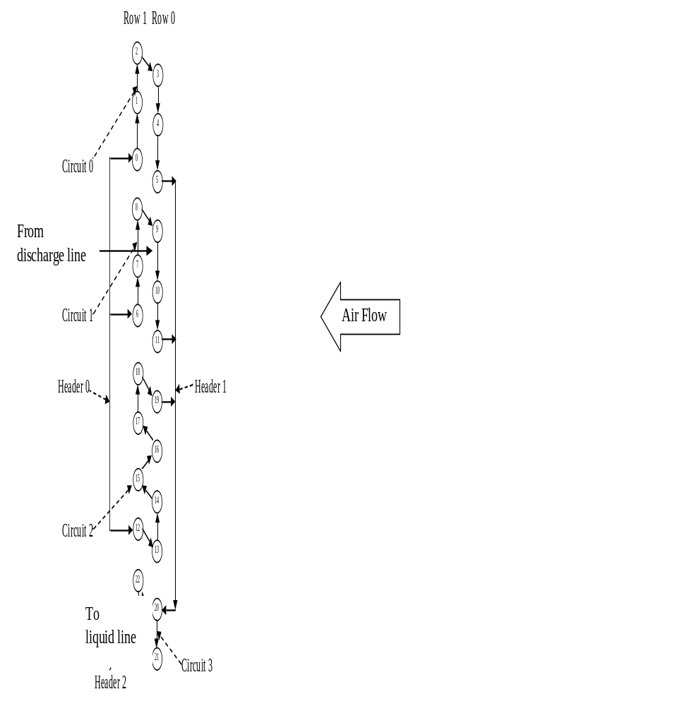
Figure M-1: Condenser circuiting pattern
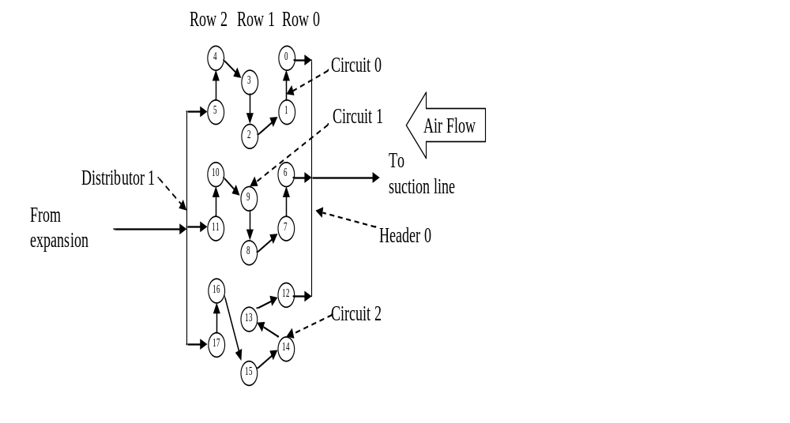
Figure M-2: Evaporator circuiting pattern

All the elements are marked using integers starting from zero. Elements of a condenser are counted from its entrance in the order of the refrigerant flow direction. However, elements of an evaporator are counted from its exit in the order of the reversed refrigerant flow direction. The row number facing the inlet air is defined as zero, and the back rows are marked with ascending numbers.
The number of “-1” has special meanings. At the air side, “-1” means the tube faces directly to the inlet air. At the refrigerant side, “-1” means the element is connected to the entrance line or exit line of the heat exchanger.
Each element is described using a single data line in a file. There are four sections in the data file, which are separated with blank lines. The first section contains the overall information of the heat exchanger; the second section contains the information of all the headers/distributors; the third section contains the information of all the circuits; the fourth section contains the information of all the tubes.
For describing a header/distributor element, the first number of the data line means No. of the header/distributor. The second number indicates how many circuits flowing into the header/distributor in a condenser, or how many circuits flowing out of the header/distributor in an evaporator. The third number indicates how many circuits flowing out of the header/distributor in a condenser, or how many circuits flowing into the header/distributor in an evaporator. After the third number, for a condenser, the following numbers indicate the circuits flowing into the header/distributor at first, and then the circuits flowing out of the header/distributor. For an evaporator, the following numbers indicate the circuits flowing out of the header/distributor at first, and then the circuits flowing into the header/distributor. For defining the circuits connected to the header/distributor, “-1” means the connected circuit is the inlet or outlet line of the heat exchanger, like the discharge line or liquid line of a condenser, or the distribution line or suction line of an evaporator.
For describing a circuit element, the first number of the data line means No. of the circuit. The second number indicates if the circuit has an equivalent circuit that has been defined before the present data line. If so, it is not necessary to perform analysis for this circuit, which can get its parameters the same as its equivalent circuit. Here, “-1” means it has no equivalent circuit. The third number indicates the refrigerant mass flow distribution ratio of the circuit, which is multiplied with the average refrigerant mass flow rate to produce the particular refrigerant mass flow rate of the circuit. This is how non-uniform refrigerant mass flow distribution is specified in the heat exchanger modeling. The fourth number means how many tubes are located in this circuit. The following numbers since the fifth give No. of the tubes in the circuit. For a condenser, the tubes are counted in the order of the refrigerant flow direction. For an evaporator, the tubes are counted in the order of the reversed refrigerant flow direction.
For describing a tube element, the first number of the data line means No. of the tube. The second number means its row number. The third number indicates the refrigerant side upstream tube No. in a condenser, or the refrigerant side downstream tube No. in an evaporator. Here, “-1” means the tube is connected to the inlet or outlet line of the heat exchanger. The fourth and fifth numbers means No. of its two upstream tubes at air side. Here, “-1” means this side of air is directly from the inlet air. The sixth number indicates the air flow allocation ratio for the single tube, which is multiplied with the average air flow rate to give the particular mass flow rate of the single tube. This is how non-uniform air flow allocation is specified in the heat exchanger modeling. The seventh number is used to define two directions of the refrigerant flow, which should be either “0” or “1”. As seen in Figure M-1, the refrigerant can flow inward or outward according to the drawing. If the inward refrigerant flow direction is defined as “0”, the outward refrigerant flow direction should be defined as “1”.
Table M-1 and Table M-2 explicate the data files for describing the circuiting patterns of the condenser and the evaporator shown in Figure M-1 and Figure M-2, respectively.
Table M-1: Example of “CondStruc.in”
Line No. | Inputs of “CondStruc.in” |  |  |  |  |  |  |  |  |  |  |  |  |  |  |  |  |  |  |  |  |  | Interpretations
1 | Overall Circuiting Information |  |  |  |  |  |  |  |  |  |  |  |  |  |  |  |  |  |  |  |  |  | Blank line
2 | 3 |  |  |  |  |  |  |  |  |  |  |  |  |  |  |  |  |  |  |  |  |  | Total number of headers/distributors
3 | 4 |  |  |  |  |  |  |  |  |  |  |  |  |  |  |  |  |  |  |  |  |  | Total number of circuits
4 | 2 |  |  |  |  |  |  |  |  |  |  |  |  |  |  |  |  |  |  |  |  |  | Total number of rows
5 | 24 |  |  |  |  |  |  |  |  |  |  |  |  |  |  |  |  |  |  |  |  |  | Total number of tubes
6 | 10 |  |  |  |  |  |  |  |  |  |  |  |  |  |  |  |  |  |  |  |  |  | Segment number per tube
7 | 0.85 |  |  |  |  |  |  |  |  |  |  |  |  |  |  |  |  |  |  |  |  |  | Frontal area [m²]
8 | 1.6 |  |  |  |  |  |  |  |  |  |  |  |  |  |  |  |  |  |  |  |  |  | Nominal air flow rate [m³/s]
9 | The followings describe the header/distributor elements |  |  |  |  |  |  |  |  |  |  |  |  |  |  |  |  |  |  |  |  |  | Blank line
10 | 0 |  | 1 |  | 3 |  |  | -1 |  |  |  | 0 |  |  | 1 |  |  |  | 2 |  |  |  | The first number “0” means the header No.; the second number “1” means one line flowing into the header; the third number “3” means three circuits flowing out of the header; the fourth number “-1” means that the refrigerant flowing into the header is from the discharge line; the following numbers from “0” to “2” mean No. of the circuits flowing out of the header.
11 | 1 |  | 3 |  | 1 |  |  | 0 |  |  |  | 1 |  |  | 2 |  |  |  | 3 |  |  |  | The first number “1” means the header No.; the second number “3” means three circuits flowing into the header; the third number “1” means one circuit flowing out of the header; the following numbers from “0” to “2” mean No. of the circuits flowing into the header; the following number “3” mean No. of the circuit flowing out of the header.
12 | 2 |  | 1 |  | 1 |  |  | 3 |  |  |  | -1 |  |  |  |  |  |  |  |  |  |  | The first number “2” means the header No.; the second number “1” means one circuit flowing into the header; the third number “1” means one circuit flowing out of the header; the fourth number “3” means the circuit No. flowing into the header; the fifth number “-1” means the refrigerant flowing out of the header to the liquid line.
13 | The followings describe the circuit elements |  |  |  |  |  |  |  |  |  |  |  |  |  |  |  |  |  |  |  |  |  | Blank line
14 | 0 | -1 | 1 | 6 |  |  | 0 |  | 1 |  | 2 |  |  | 3 |  | 4 |  | 5 |  |  |  |  | The first number “0” means the circuit No.; the second number “-1” means it has no equivalent circuit; the third number “1” means the refrigerant flow distribution ratio of the circuit; the fourth number “6” means there are six tubes in the circuit; the following numbers from “0” to “5” mean No. of the tubes in the refrigerant flow direction in the circuit.
15 | 1 | 0 | 1 | 6 |  |  | 6 |  | 7 |  | 8 |  |  | 9 |  | 10 |  | 11 |  |  |  |  | The first number “1” means the circuit No.; the second number “0” means the circuit is equivalent to Circuit 0; the third number “1” means the refrigerant flow distribution ratio; the fourth number “6” means there are six tubes in the circuit; the following numbers from “6” to “11” mean the tube No. in the refrigerant flow direction in the circuit.
16 | 2 | -1 | 1 | 8 |  |  | 12 |  | 13 |  | 14 |  |  | 15 |  | 16 |  | 17 |  | 18 |  | 19 | The first number “2” means the circuit No.; the second number “-1” means no equivalent circuit; the third number “1” means the refrigerant flow distribution ratio of the circuit; the fourth number “8” means there are eight tubes in the circuit; the following numbers from “12” to “19” mean the tube No in the refrigerant flow direction in the circuit.
17 | 3 | -1 | 1 | 4 |  |  | 20 |  | 21 |  | 22 |  |  | 23 |  |  |  |  |  |  |  |  | The first number “3” means the circuit No.; the second number “-1” means no equivalent circuit; the third number “1” means the refrigerant flow distribution ratio of the circuit; the fourth number “4” means there are four tubes in the circuit; the following numbers from “20” to “23” mean the tube No. in the refrigerant flow direction in the circuit.
18 | The followings describe the tube elements |  |  |  |  |  |  |  |  |  |  |  |  |  |  |  |  |  |  |  |  |  | Blank line
19 | #No |  | #Row |  |  | #Ref |  |  |  | #up |  |  | #down |  |  |  | #GaF |  |  |  | #Dirc |  | Blank line
20 | 0 |  | 1 |  |  | -1 |  |  |  | 4 |  |  | 5 |  |  |  | 1 |  |  |  | 0 |  | The section describes the information of all the tubes, where each data line has the same number of columns. The first column “#No” means the tube No.. The second column “#Row” means the row No, where the tube locates; The third column “#Ref” means the upstream tube number in the refrigerant flow direction. If the number in the third column is “-1”, it means the upstream refrigerant side tube is the discharge line. The fourth column “#up” and fifth column “#down” mean the two upstream tubes at the air side. If one number in the fourth or fifth column is “-1”, it means the air at this side is the inlet air of the heat exchanger. The sixth column “#GaF” means the air flow allocation ratio of the single tube. The seventh column “#Dirc” means the direction of refrigerant flowing from one side to the other side of the heat exchanger. For example, if “0” means the refrigerant flowing in one direction, then “1” means the opposite direction.
21 | 1 |  | 1 |  |  | 0 |  |  |  | 3 |  |  | 4 |  |  |  | 1 |  |  |  | 1
22 | 2 |  | 1 |  |  | 1 |  |  |  | -1 |  |  | 3 |  |  |  | 1 |  |  |  | 0
23 | 3 |  | 0 |  |  | 2 |  |  |  | -1 |  |  | -1 |  |  |  | 1 |  |  |  | 1
24 | 4 |  | 0 |  |  | 3 |  |  |  | -1 |  |  | -1 |  |  |  | 1 |  |  |  | 0
25 | 5 |  | 0 |  |  | 4 |  |  |  | -1 |  |  | -1 |  |  |  | 1 |  |  |  | 1
26 | 6 |  | 1 |  |  | -1 |  |  |  | 10 |  |  | 11 |  |  |  | 1 |  |  |  | 0
27 | 7 |  | 1 |  |  | 6 |  |  |  | 9 |  |  | 10 |  |  |  | 1 |  |  |  | 1
28 | 8 |  | 1 |  |  | 7 |  |  |  | 5 |  |  | 9 |  |  |  | 1 |  |  |  | 0
29 | 9 |  | 0 |  |  | 8 |  |  |  | -1 |  |  | -1 |  |  |  | 1 |  |  |  | 1
30 | 10 |  | 0 |  |  | 9 |  |  |  | -1 |  |  | -1 |  |  |  | 1 |  |  |  | 0
31 | 11 |  | 0 |  |  | 10 |  |  |  | -1 |  |  | -1 |  |  |  | 1 |  |  |  | 1
32 | 12 |  | 1 |  |  | -1 |  |  |  | 14 |  |  | 13 |  |  |  | 1 |  |  |  | 0
33 | 13 |  | 0 |  |  | 12 |  |  |  | -1 |  |  | -1 |  |  |  | 1 |  |  |  | 1
34 | 14 |  | 0 |  |  | 13 |  |  |  | -1 |  |  | -1 |  |  |  | 1 |  |  |  | 0
35 | 15 |  | 1 |  |  | 14 |  |  |  | 16 |  |  | 14 |  |  |  | 1 |  |  |  | 1
36 | 16 |  | 0 |  |  | 15 |  |  |  | -1 |  |  | -1 |  |  |  | 1 |  |  |  | 0
37 | 17 |  | 1 |  |  | 16 |  |  |  | 19 |  |  | 16 |  |  |  | 1 |  |  |  | 1
38 | 18 |  | 1 |  |  | 17 |  |  |  | 11 |  |  | 19 |  |  |  | 1 |  |  |  | 0
39 | 19 |  | 0 |  |  | 18 |  |  |  | -1 |  |  | -1 |  |  |  | 1 |  |  |  | 1
40 | 20 |  | 0 |  |  | -1 |  |  |  | -1 |  |  | -1 |  |  |  | 1 |  |  |  | 0
41 | 21 |  | 0 |  |  | 20 |  |  |  | -1 |  |  | -1 |  |  |  | 1 |  |  |  | 1
42 | 22 |  | 1 |  |  | 21 |  |  |  | 13 |  |  | 20 |  |  |  | 1 |  |  |  | 0
43 | 23 |  | 1 |  |  | 22 |  |  |  | 20 |  |  | 21 |  |  |  | 1 |  |  |  | 1
44 | -256 |  |  |  |  |  |  |  |  |  |  |  |  |  |  |  |  |  |  |  |  |  | End sign of the section for defining circuiting pattern.
45 | 0.5 |  |  |  |  |  |  |  |  |  |  |  |  |  |  |  |  |  |  |  |  |  | Fixed amount charge tuning mass [kg]
46 | 5.0 |  |  |  |  |  |  |  |  |  |  |  |  |  |  |  |  |  |  |  |  |  | Reference liquid length for charge tuning [m]
47 | 0.03 |  |  |  |  |  |  |  |  |  |  |  |  |  |  |  |  |  |  |  |  |  | Coefficient relates the charge modeling errors to liquid length in the condenser [kg/m]
48 | -256 |  |  |  |  |  |  |  |  |  |  |  |  |  |  |  |  |  |  |  |  |  | End sign of the input file.

Table M-2: Example of “EvapStruc.in”
Line No. | Inputs of “EvapStruc.in” |  |  |  |  |  |  |  |  |  |  |  |  |  |  |  |  |  |  |  |  | Interpretations
1 | Overall Circuiting information |  |  |  |  |  |  |  |  |  |  |  |  |  |  |  |  |  |  |  |  | Blank line
2 | 2 |  |  |  |  |  |  |  |  |  |  |  |  |  |  |  |  |  |  |  |  | Total number of headers/distributors
3 | 3 |  |  |  |  |  |  |  |  |  |  |  |  |  |  |  |  |  |  |  |  | Total number of circuits
4 | 3 |  |  |  |  |  |  |  |  |  |  |  |  |  |  |  |  |  |  |  |  | Total number of rows
5 | 18 |  |  |  |  |  |  |  |  |  |  |  |  |  |  |  |  |  |  |  |  | Total number of tubes
6 | 10 |  |  |  |  |  |  |  |  |  |  |  |  |  |  |  |  |  |  |  |  | Segment number per tube
7 | 0.34 |  |  |  |  |  |  |  |  |  |  |  |  |  |  |  |  |  |  |  |  | Frontal area [m²]
8 | 0.67 |  |  |  |  |  |  |  |  |  |  |  |  |  |  |  |  |  |  |  |  | Nominal air flow rate [m³/s]
9 | The followings describe the header/distributor elements |  |  |  |  |  |  |  |  |  |  |  |  |  |  |  |  |  |  |  |  | Blank line
10 | 0 |  |  | 1 |  |  | 3 |  |  |  | -1 |  |  | 0 |  |  |  | 1 |  | 2 |  | The first number “0” means the header No.; the second number “1” means one line flowing out of the header; the third number “3” means three circuits flowing into the header; the fourth number “-1” means refrigerant flowing out of the header to the suction line; the following numbers from “0” to “2” mean No. of the circuits flowing into the header.
11 | 1 |  |  | 3 |  |  | 1 |  |  |  | 0 |  |  | 1 |  |  |  | 2 |  | -1 |  | The first number “1” means the distributor No.; the second number “3” means three circuits flowing out of the header; the third number “1” means one line flowing into the distributor; the following numbers from “0” to “2” mean No. of the circuits. flowing out of the distributor; the last number “-1” means refrigerant flowing into the distributor from the distribution line or expansion.
12 | The followings describe the circuit elements |  |  |  |  |  |  |  |  |  |  |  |  |  |  |  |  |  |  |  |  | Blank line
13 | 0 | -1 |  |  | 1 |  |  | 6 |  | 0 |  | 1 |  |  | 2 |  | 3 |  | 4 |  | 5 | The first number “0” means the circuit No.; the second number “-1” means it has no equivalent circuit; the third number “1” means the refrigerant flow distribution ratio of the circuit; the fourth number “6” means there are six tubes in the circuit; the following numbers from “0” to “5” mean No. of the tubes in the reversed refrigerant flow direction in the circuitt.
14 | 1 | 0 |  |  | 1 |  |  | 6 |  | 6 |  | 7 |  |  | 8 |  | 9 |  | 10 |  | 11 | The first number “1” means the circuit No.; the second number “0” means it is equivalent to Circuit 0; the third number “1” means the refrigerant flow distribution ratio of the circuit; the fourth number “6” means there are six tubes in the circuit; the following numbers from “6” to “11” mean No. of the tubes in the reversed refrigerant flow direction in the circuit.
15 | 2 | -1 |  |  | 1 |  |  | 6 |  | 12 |  | 13 |  |  | 14 |  | 15 |  | 16 |  | 17 | The first number “2” means the circuit No.; the second number “-1” means no equivalent circuit of it; the third number “1” means the refrigerant flow distribution ratio of the circuit; the fourth number “6” means there are six tubes in the circuit; the following numbers from “12” to “17” mean No. of the tubes in the reversed refrigerant flow direction in the circuit.
16 | The followings describe the tube elements |  |  |  |  |  |  |  |  |  |  |  |  |  |  |  |  |  |  |  |  | Blank line
17 | #No |  | #Row |  |  | #Ref |  |  | #up |  |  |  | #down |  |  | #GaF |  |  |  | #Dirc |  | Blank line
18 | 0 |  | 0 |  |  | -1 |  |  | -1 |  |  |  | -1 |  |  | 1 |  |  |  | 0 |  | The section describes the information of all the tubes. The first column “#No” means the tube No.. The second column “#Row” means the row No, where the tube locates; The third column “#Ref” means its downstream tube No. in the refrigerant flow direction. If the number in the third column is “-1”, it means its downstream tube at refrigerant side is the suction line. The fourth column “#up” and fifth column “#down” mean its two upstream tubes at the air side. If the number in the fourth or fifth column is “-1”, it means the upstream air at this side is the inlet air of the heat exchanger. The sixth column “#GaF” means the air flow allocation ratio of the single tube. The seventh column “#Dirc” means the direction of refrigerant flowing from one side to the other side of the heat exchanger. For example, if “0” means the refrigerant flowing in one direction, then “1” means the opposite direction.
19 | 1 |  | 0 |  |  | 0 |  |  | -1 |  |  |  | -1 |  |  | 1 |  |  |  | 1
20 | 2 |  | 1 |  |  | 1 |  |  | 1 |  |  |  | 6 |  |  | 1 |  |  |  | 0
21 | 3 |  | 1 |  |  | 2 |  |  | 0 |  |  |  | 1 |  |  | 1 |  |  |  | 1
22 | 4 |  | 2 |  |  | 3 |  |  | -1 |  |  |  | 3 |  |  | 1 |  |  |  | 0
23 | 5 |  | 2 |  |  | 4 |  |  | 3 |  |  |  | 2 |  |  | 1 |  |  |  | 1
24 | 6 |  | 0 |  |  | -1 |  |  | -1 |  |  |  | -1 |  |  | 1 |  |  |  | 0
25 | 7 |  | 0 |  |  | 6 |  |  | -1 |  |  |  | -1 |  |  | 1 |  |  |  | 1
26 | 8 |  | 1 |  |  | 7 |  |  | 7 |  |  |  | 12 |  |  | 1 |  |  |  | 0
27 | 9 |  | 1 |  |  | 8 |  |  | 6 |  |  |  | 7 |  |  | 1 |  |  |  | 1
28 | 10 |  | 2 |  |  | 9 |  |  | 2 |  |  |  | 9 |  |  | 1 |  |  |  | 0
29 | 11 |  | 2 |  |  | 10 |  |  | 9 |  |  |  | 8 |  |  | 1 |  |  |  | 1
30 | 12 |  | 0 |  |  | -1 |  |  | -1 |  |  |  | -1 |  |  | 1 |  |  |  | 0
31 | 13 |  | 1 |  |  | 12 |  |  | 12 |  |  |  | 14 |  |  | 1 |  |  |  | 1
32 | 14 |  | 0 |  |  | 13 |  |  | -1 |  |  |  | -1 |  |  | 1 |  |  |  | 0
33 | 15 |  | 1 |  |  | 14 |  |  | 14 |  |  |  | -1 |  |  | 1 |  |  |  | 1
34 | 16 |  | 2 |  |  | 15 |  |  | 8 |  |  |  | 13 |  |  | 1 |  |  |  | 0
35 | 17 |  | 2 |  |  | 16 |  |  | 13 |  |  |  | 15 |  |  | 1 |  |  |  | 1
36 | -256 |  |  |  |  |  |  |  |  |  |  |  |  |  |  |  |  |  |  |  |  | End sign of the section for defining circuiting pattern.
37 | 0 |  |  |  |  |  |  |  |  |  |  |  |  |  |  |  |  |  |  |  |  | Fixed amount charge tuning mass [kg]
38 | 0 |  |  |  |  |  |  |  |  |  |  |  |  |  |  |  |  |  |  |  |  | Reference vapor length for charge tuning [m]
39 | 0 |  |  |  |  |  |  |  |  |  |  |  |  |  |  |  |  |  |  |  |  | Coefficient relates the charge modeling errors to vapor length in the evaporator [kg/m]
40 | -256 |  |  |  |  |  |  |  |  |  |  |  |  |  |  |  |  |  |  |  |  | End sign of the input file.

